## Experiment No. : 10

**Title:** Parameterized Report creation using SQL Server Reporting Services

**Objectives**: 1. To Create Parameterized Report using SQL Server Reporting Services

**Key concepts:** Parameterized Report, SSRS

**Steps to create Parameterized Report using SQL Server Reporting Services**

Create Shared Data Source and Dataset as per guidelines given in Exp No 9 and for below given query

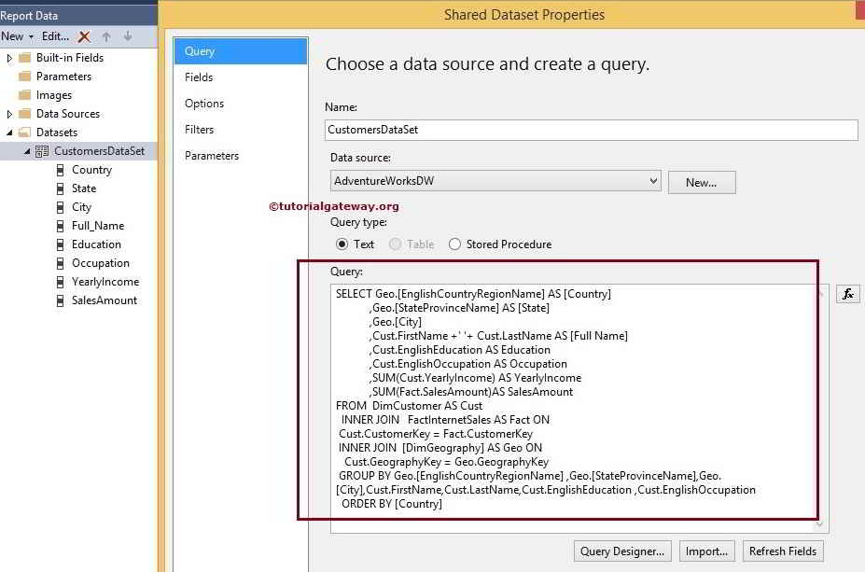

[SQL](https://www.tutorialgateway.org/sql/) Command we used in the above screenshot is:

SELECT Geo.[EnglishCountryRegionName] AS [Country]

,Geo.[StateProvinceName] AS [State]

,Geo.[City]

,Cust.FirstName +' '+ Cust.LastName AS [Full Name]

,Cust.EnglishEducation AS Education

,Cust.EnglishOccupation AS Occupation

,SUM(Cust.YearlyIncome) AS YearlyIncome

,SUM(Fact.SalesAmount)AS SalesAmount

FROM DimCustomer AS Cust

INNER JOIN

FactInternetSales AS Fact ON

Cust.CustomerKey = Fact.CustomerKey

INNER JOIN

[DimGeography] AS Geo ON

Cust.GeographyKey = Geo.GeographyKey

GROUP BY Geo.[EnglishCountryRegionName]

,Geo.[StateProvinceName]

,Geo.[City]

,Cust.FirstName

,Cust.LastName

,Cust.EnglishEducation

,Cust.EnglishOccupation

ORDER BY [Country]

## Adding SSRS Report Parameters

To add SSRS Report Parameters, Right Click on the **Parameters** Folder present in the **Report Data** tab will open the Context Menu to select **Add parameters..** option.

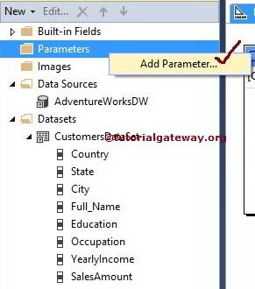

Once you click on **Add parameters..** option opens a new window called Report parameter Properties to configure the parameter properties in SSRS.

* **Name:** Please specify the valid Parameter name as per your requirement. Here, we defined it as CountryParameter
* **Prompt:** The text you specified here will display as a label before the text box
* **Data Type:** Country name is a Text data type so, we kept the default text unchanged

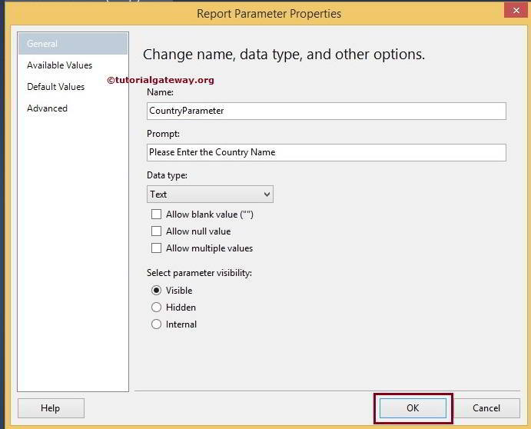

Click Ok to finish configuring the Report parameters in SSRS. Now, We have to apply filter condition on the Dataset.

Select the Dataset from the Report data tab, and right-click on it will open the context menu. Please select the **Dataset Properties..** option from it

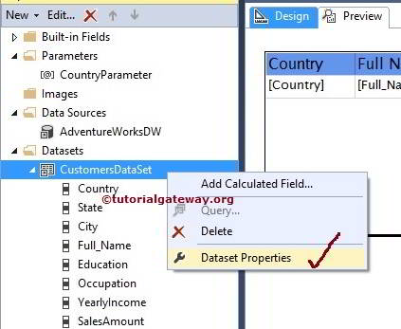

In this SSRS report parameters example, We are going to display the records whose [Country Name] is equal to [Country Parameter] we just created. So, Please select the Country as **Expression** and Operator as [Like Operator](https://www.tutorialgateway.org/sql-like/) and Value as Parameter name.

If you find any difficult to write the parameter name, Please click on the **fx** button and select the parameter name from the GUI.

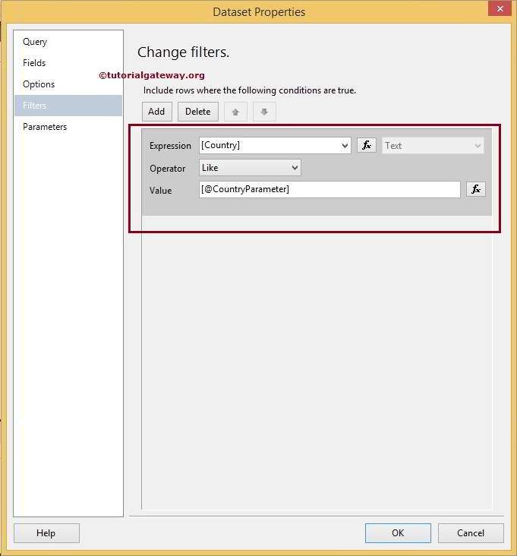

Click Ok to finish configuring the Filters at Dataset Level. Drag Matrix in canvas. Drag dataset columns in the matrix columns as shown in the preview.

Let’s click on the Preview Tab to preview the SSRS Report Parameters Data.

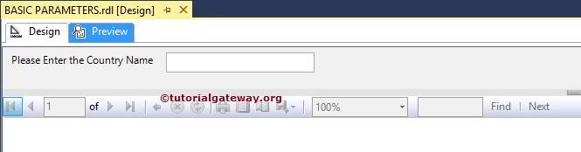

From the above screenshot, you can observe that It is displaying a Blank Report with Empty Textbox on Top. To view the records, we have to enter the Country Name in that Textbox and Press Enter.

For now, We are entering Germany as Country Name.After entering Germany as country name it displays all the record having Germany as country in data matrix as shown below.

